ConExpo/ConAgg 2023
Expanded Continental Radio Program Provides Advanced Range of Analog and CAN Radio Features
• Ideal for OE and retrofit as well as aftermarket replacement and upgrade
• Available in 12V and 24V with speakers, antennas, and accessories

Las Vegas, NV, March 14, 2023 — Continental, a leading global supplier of systems, components, and tires to automobile, truck, and agriculture/construction equipment manufacturers, and a trusted provider of OE-engineered aftermarket parts, offers its expanded single DIN radio line with advanced radio platforms engineered to deliver durability and reliability under rugged use and high vibration.
Continental radios are designed for easy installation on small and medium trucks, agricultural and construction equipment, off highway vehicles, buses and motorcoaches, recreational vehicles, campers, and trailers. The easy to install and durable design makes the radio line ideal for use in construction and mining applications.
Continental radios offer exceptional sound quality, style, and functionality and are offered in both analog and CAN platforms for 12V and 24V applications. The radios are available with a variety of options including AM/FM Worldwide RDS-Receiver, DAB tuner, Bluetooth, MP3/WMA playback, CD player, USB, mix audio input, 30-day clock, non-volatile memory for settings and sound presets, ISO 104787 connector, and additional auxiliary inputs.

OE and retrofit applications
For OE and retrofit, the innovative CAN designs offer a systems approach that allows for perfect integration with vehicle controls and other HMI devices via CAN J1939. With display or Black box version, the units allow for use with steering wheel or armrest controls, integration with existing displays, and Bluetooth capability. Accessories such as additional external microphones and auxiliary cables for added inputs are also available.

The functional design and exceptional sound quality of Continental’s analog models make them an ideal choice for replacement or upgrade in any aftermarket application. The radios are designed with an intuitive interface, along with large buttons and turn keys with grip for ease of use and straightforward access to a sophisticated range of functionality and user features.

Speakers and antennas
Continental offers a wide range of AM/FM antennas for roof or windscreen mounting, along with various lengths of extension cables from 1.5 to 2.8 m and adapters for wide application coverage. Continental’s speaker line is designed to provide dynamic sound quality with all Continental radios. The speakers are available in 100mm and 130mm diameter sizes and sold as pairs with grilles, or in bulk with speakers and grilles separately as needed for OE installations.
Continental develops pioneering technologies and services for sustainable and connected mobility of people and their goods. Founded in 1871, the technology company offers safe, efficient, intelligent and affordable solutions for vehicles, machines, traffic and transportation. In 2021, Continental generated sales of €33.8 billion and currently employs more than 190,000 people in 58 countries and markets. On October 8, 2021, the company celebrated its 150th anniversary.
Continental offers a wide-ranging portfolio for off-highway applications which makes construction, agricultural and transport machinery and vehicles safer, more efficient, more comfortable and more connected. The corporation supplies interdivisional solutions for monitoring the condition of components and systems as well as technologies for information management, rubber and plastic products, and tires – all tailor-made and from a single source.

Press contact

Anouré Fenstermaker
Marketing Communications Manager, North America
Smart Mobility
Phone: +1 (484) 705-1909‬‬‬‬‬‬‬‬‬‬

Email: Anoure.Fenstermaker@continental-corporation.com

Press portal: www.continentalaftermarket.com/conexpo

pictures/captions\

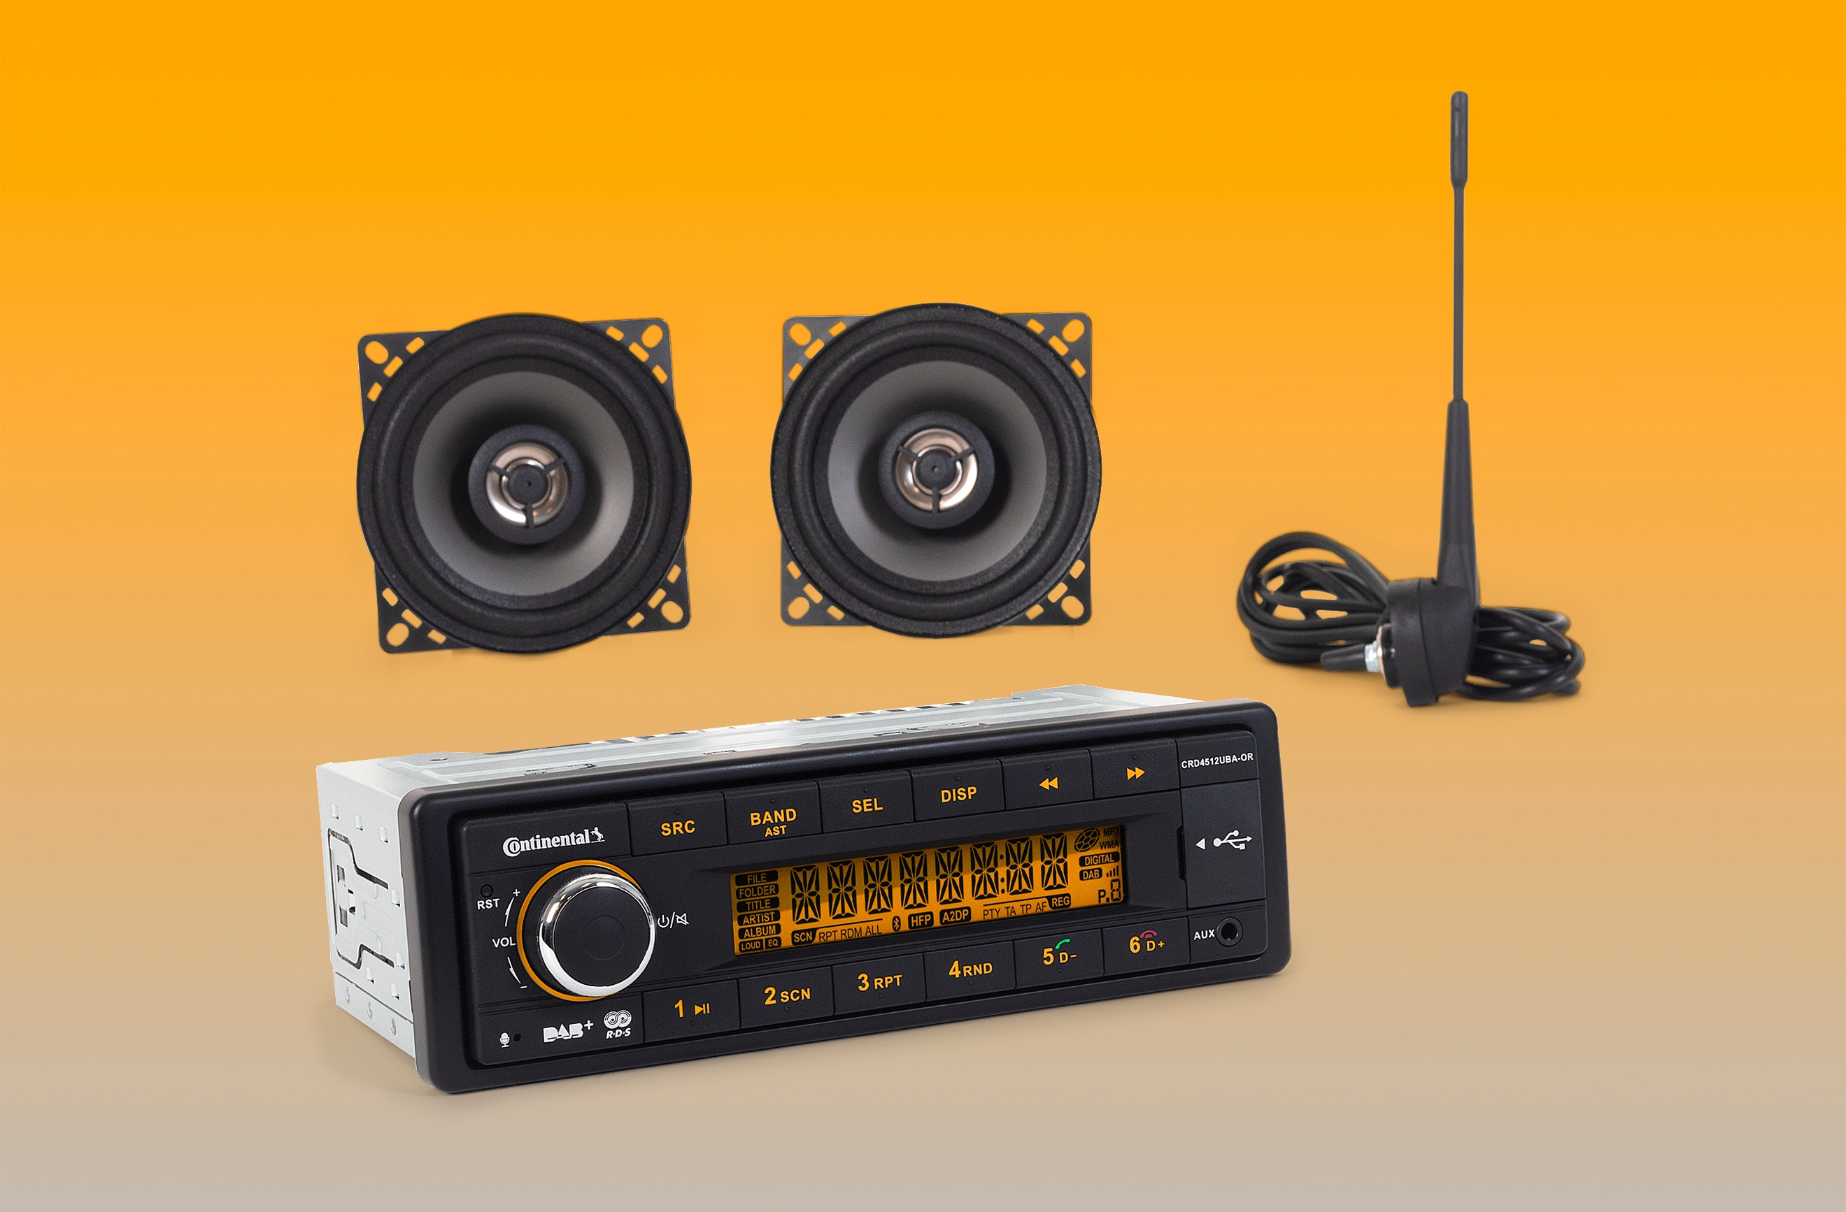
Continental radios are engineered to deliver durability and reliability under rugged use and high vibration.

Continnetal-Radio-Speakers-Antenna-Gp.jpg

