Press release

ess Release

Press Release

Press Release

Press Release

Press Release

Press Release

Press Release

Press Release

ess Release

Press Release

Press Release

Press Release

Press Release

Press Release

Press Release

Press Release

Press Release

ess Release

Press Release

Press Release

Press Release

Press Release

Press Release

Press Release

Press Release

ess Release

Press Release

Press Release

Press Release

Press Release

Press Release

Press Release

Press Release

Press Release

ess Release

Press Release

Press Release

Press Release

Press Release

Press Release

Press Release

Press Release

ess Release

Press Release

Press Release

Press Release

Press Release

Press Release

Press Release

Press Release

Press Release

ess Release

Press Release

Press Release

Press Release

Press Release

Press Release

Press Release

Press Release

ess Release

Press Release

Press Release

Press Release

Press Release

Press Release

Press Release

Press Release

ATE Brake Pads Offered in Over 150 Formulations
- Friction materials are precisely formulated to match OE pads' performance
- “ATE Original” brake pad line includes semi-metallic, ceramic formulations
- 293-part numbers provide coverage for over 104 million VIO
Allentown, PA July 21, 2023 – Continental offer the ATE Original line of brake pads in over 150 different friction material formulations. The ATE Brake Pad line includes 293 part numbers with application coverage for over 104 million vehicles in operation. ATE, the premium brake brand of the German automotive supplier, offers this huge range of pad compound formulations so that brake pad friction materials can precisely match the OE pad’s specifications. This helps ensure that braking performance is the same as when the car left the dealership.
“Many aftermarket brake manufacturers traditionally offered three pad formulations: good, better, and best… and some still do,” notes Dan Caciolo, Head of Product Management at Continental. “We believe that every year, make, and model deserves the ideal brake pad. With over 150 different pad compounds we have exactly the right product for every vehicle – and the best range for our customers.”
ATE (www.ate-na.com) is the premium aftermarket brand of Continental, one of the world's largest brake system manufacturers and suppliers. From the introduction of the first hydraulic brake system in 1926, to the development of the first antilock braking system prototype in 1967, to the ATE Ceramic low-dust brake pads, the ATE brand has a rich history of innovation and experience in the design and production of advanced brake system technologies.
For more information: www.ate-na.com or contact: salessupport-us@ate-na.com
Continental is a leading aftermarket supplier of OE-engineered parts for HVAC and engine cooling, door systems, tire pressure monitoring systems, engine management, fuel systems, instrumentation, as well as automotive diagnostic systems, premium wiper blades, air, cabin, fuel, and oil filters, and brake system parts and fluid.

Continental develops pioneering technologies and services for sustainable and connected mobility of people and their goods. Founded in 1871, the technology company offers safe, efficient, intelligent and affordable solutions for vehicles, machines, traffic and transportation. In 2022, Continental generated sales of €39.4 billion and currently employs around 200,000 people in 57 countries and markets.
Drawing on more than 120 years of cooperation with vehicle manufacturers, Continental offers a broad range of spare parts in OEM quality for the aftermarket. Under brands like Continental, ATE, VDO,
REDI-Sensor, ClearContact, Autodiagnos, Uniroyal, Semperit, and GALFER, the technology company manufactures tens of thousands of products, including tires, brakes, drive components and thermal management components. It also provides diagnostic solutions, tools and services for repair shops. Continental is one of the most important suppliers in the independent automotive aftermarket.

Press Contact

Anouré V. Fenstermaker
Marketing Communications Manager
Continental Automotive Systems, Inc.
Automotive Aftermarket, North America
Smart Mobility (SMY)
6755 Snowdrift Road, Allentown, PA 18106
Tel: (484) 705-1909, Fax: (610) 289-1766
Email: anoure.fenstermaker@continental.com

198-23/CO8543

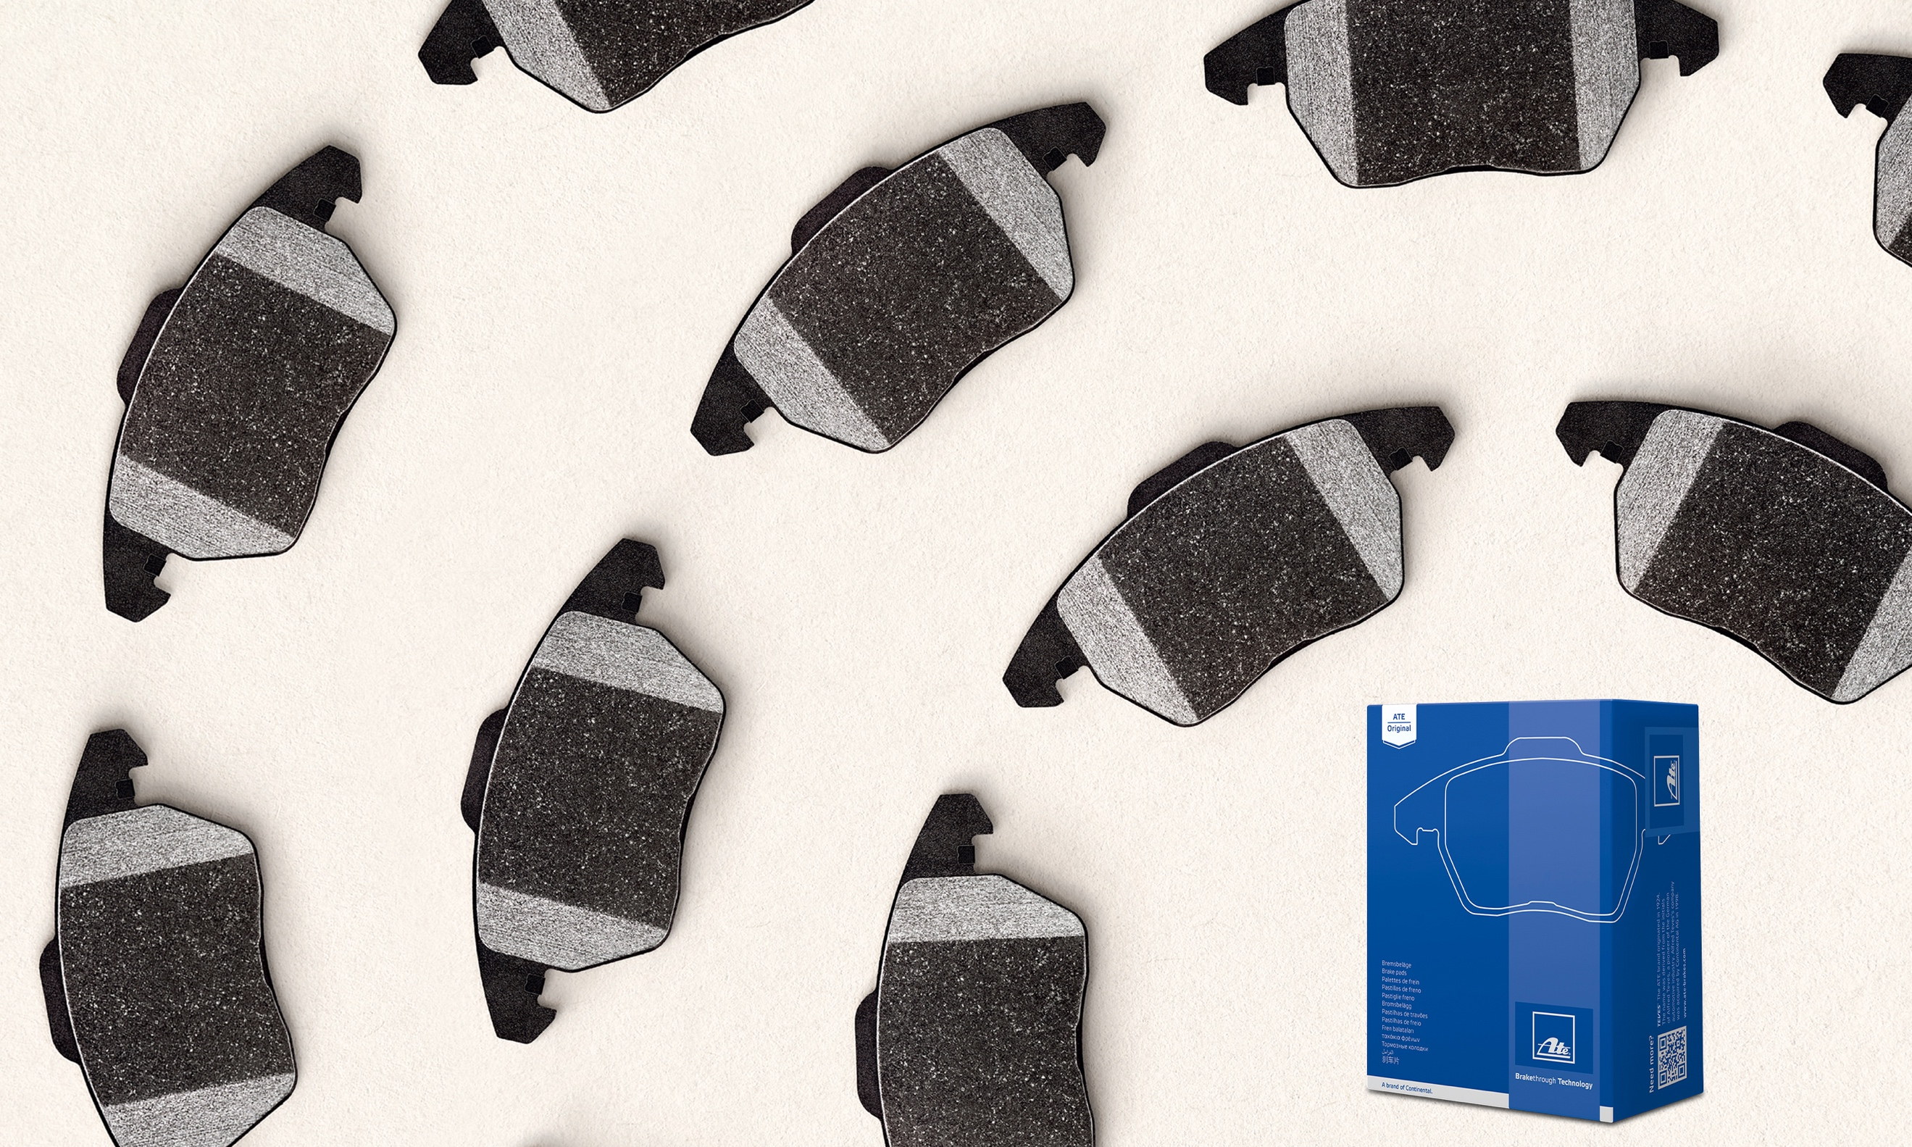  ATE_Original”_brake_pad_line.jpg | The “ATE Original” brake pad line includes over 150 brake pad compound formulations.

