Continental Offers Autodiagnos TPMS Tools and REDI-Sensor TPMS Sensors in a Turnkey Bundle
- Offer is available for both Autodiagnos D, Autodiagnos SE TPMS tools
- Offer leverages built-in compatibility of Continental products
- Provides significant savings to service pros and shops
Las Vegas, NV, October 31, 2023 — Continental is now offering TPMS ‘Tool Bundles’ that combine the company’s Autodiagnos TPMS Tools with Continental’s REDI-Sensor TPMS Sensors.
According to Peter Dobrowolski, Continental Product Manager for TPMS and TPMS Tools, “Autodiagnos TPMS Tools and REDI-Sensor TPMS Sensors were engineered to work together flawlessly, so our bundle promo is a natural. Plus, the bundles represent hundreds of dollars in savings compared to the individual product pricing, and having Autodiagnos and REDI-Sensor on hand lets shops tackle TPMS service with the utmost confidence and speed.”
One bundle combines the Autodiagnos TPMS D Tool with a mix of 24 REDI-Sensors: four each of the SE10005 and SE10008 and eight each of the SE10006 and SE10007. The other bundle includes the Autodiagnos TPMS SE Tool with a mix of 12 REDI-Sensors: two each of the SE10005 and SE10008 and four each of the SE10006 and SE10007.
The Autodiagnos D Tool triggers, diagnoses, and reads 100% of OE and aftermarket passenger vehicle sensors. It provides complete TPMS diagnostics and can read and clear codes. In OBD-II mode, it relearns sensors in under 2 minutes. Five years of free software updates are included with the tool purchase. The Autodiagnos SE Tool also triggers, diagnoses, and reads 100% of OE and aftermarket passenger vehicle sensors. It has relearn coverage for over 95% of domestic, Asian, and European passenger vehicles, and it too includes five years of free software updates with the tool purchase.
The REDI-Sensor line includes four TPMS sensors that provide coverage for most passenger vehicles, SUVs, cross overs, and light trucks, from 2002 to 2023. The four REDI-Sensors replace over 300+ OE sensors with coverage that exceeds 225 million vehicles in operation.
Continental is a leading aftermarket supplier of OE-engineered parts for HVAC and engine cooling, door systems, tire pressure monitoring systems, engine management, fuel systems, instrumentation, as well as automotive diagnostic systems, premium wiper blades, air, cabin, fuel, and oil filters, and brake system parts and fluid.
For more information, visit: www.autodiagnosTPMS.com or www.redi-sensor.com or email: salessupport-us@continental.com.

Continental develops pioneering technologies and services for sustainable and connected mobility of people and their goods. Founded in 1871, the technology company offers safe, efficient, intelligent and affordable solutions for vehicles, machines, traffic and transportation. In 2022, Continental generated sales of €39.4 billion and currently employs around 200,000 people in 57 countries and markets.
Drawing on more than 120 years of cooperation with vehicle manufacturers, Continental offers a broad range of spare parts in OEM quality for the aftermarket. Under brands like Continental, ATE, VDO,
REDI-Sensor, ClearContact, Autodiagnos, Uniroyal, Semperit, and GALFER, the technology company manufactures tens of thousands of products, including tires, brakes, drive components and thermal management components. It also provides diagnostic solutions, tools and services for repair shops. Continental is one of the most important suppliers in the independent automotive aftermarket.

Press contact

Anouré V. Fenstermaker
Marketing Communications Manager
Continental Automotive Systems, Inc.
Automotive Aftermarket, North America
Smart Mobility (SMY)
6755 Snowdrift Road, Allentown, PA 18106
Tel: (484) 705-1909, Fax: (610) 289-1766
Email: anoure.fenstermaker@continental.com

Press portal: https://www.autoshowpress.com/continental-aapex/

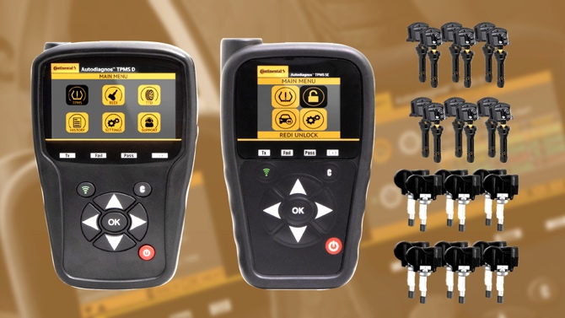  Continental-Autodiagnos-REDI-Sensor-Bundles.jpg |  | The Autodiagnos TPMS Tools / REDI-Sensor bundles represent hundreds of dollars in savings for shops and service pros.

299-23/CO8586

