ATE Electronic Parking Brake Actuators Save Time and Money on Caliper Repairs
- Offering the actuator alone ensures the caliper need not be replaced
- Coverage for Audi, BMW, Jaguar, Land Rover, Mercedes-Benz, Volkswagen, Volvo models
Las Vegas, NV, October 31, 2023 — Continental offers ATE Electronic Brake Actuators to help save both professional technicians and their customers time and money during service. Available as an individual part, separate from the whole caliper assembly, the ATE Electronic Brake Actuator allows technicians to replace only the failed actuator without replacing the entire caliper unit.
“We are offering these ATE Electronic Brake Actuators to help save time and money on repairs,” notes Nathan Killeen, Product Manager, ATE Brake Systems. “A common issue that shops see is a parking brake actuator that has failed, while the brake caliper remains in good condition. Thanks to these actuators, technicians can replace only the faulty part and get the vehicle back on the road faster, while saving their customer money at the same time. A win-win for all involved.”
Continental offers ATE Electronic Parking Brake Actuators for a number of popular European makes including Audi, BMW, Jaguar, Land Rover, Mercedes-Benz, Volkswagen, and Volvo. They provide application coverage for over 5 million vehicles-in-operation in North America.
ATE (www.ate-na.com) is an aftermarket brand of Continental, one of the world's leading brake system manufacturers and suppliers. From the introduction of the first hydraulic brake system in 1926, to the development of the first antilock braking system prototype in 1967, the ATE brand has a rich history of innovation and experience in the design and production of advanced brake system technologies.

For more information: www.ate-na.com or contact: salessupport-us@ate-na.com

Continental is a leading aftermarket supplier of OE-engineered parts for HVAC and engine cooling, door systems, tire pressure monitoring systems, engine management, fuel systems, instrumentation, as well as automotive diagnostic systems, premium wiper blades, air, cabin, fuel, and oil filters, and brake system parts and fluid.
Continental develops pioneering technologies and services for sustainable and connected mobility of people and their goods. Founded in 1871, the technology company offers safe, efficient, intelligent and affordable solutions for vehicles, machines, traffic and transportation. In 2022, Continental generated sales of €39.4 billion and currently employs around 200,000 people in 57 countries and markets.
Drawing on more than 120 years of cooperation with vehicle manufacturers, Continental offers a broad range of spare parts in OEM quality for the aftermarket. Under brands like Continental, ATE, VDO,
REDI-Sensor, ClearContact, Autodiagnos, Uniroyal, Semperit, and GALFER, the technology company manufactures tens of thousands of products, including tires, brakes, drive components and thermal management components. It also provides diagnostic solutions, tools and services for repair shops. Continental is one of the most important suppliers in the independent automotive aftermarket.

Press contact

Anouré V. Fenstermaker
Marketing Communications Manager
Continental Automotive Systems, Inc.
Automotive Aftermarket, North America
Smart Mobility (SMY)
6755 Snowdrift Road, Allentown, PA 18106
Tel: (484) 705-1909, Fax: (610) 289-1766
Email: anoure.fenstermaker@continental.com

Press portal: https://www.autoshowpress.com/continental-aapex/

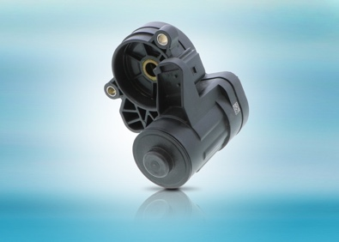
ATE-Electronic-Parking-Brake-Actuator.jpg |  | ATE Electronic Parking Brake Actuators save time for technicians time and money for their customers.
299-23/CO8586

