Continental Introduces OEM Diesel Aftertreatment Injectors for Popular Ram Models
- Coverage includes Ram 2500, 3500, 4500, 5500 models from 2013-2023
- Exact OE part simplifies installation, reduces comebacks
- Application coverage for over 1 million vehicles-in-operation across United States, Canada
Las Vegas, NV, October 31, 2023 — Continental has introduced a new Diesel Aftertreatment Injector part number. The injector provides application coverage for Ram truck models 2500, 3500, 4500, and 5500 from model years 2013 through 2023. The Diesel Aftertreatment Injector is the exact original equipment manufacturer (OEM) part and is the first part of its kind that Continental has offered to the aftermarket.
“The original Diesel Aftertreatment Injector on Ram trucks have a tendency to clog due to debris and dust particles,” notes Brendan Bachant, Continental Product Manager for Engine Management and Fuel. “They are also prone to corrosion and standard wear-and-tear. We saw the need to offer the exact OEM injector part to the aftermarket to help simplify and speed up installations for technicians. These Diesel Aftertreatment Injectors deliver peak performance and a longer service life that professionals can count on.”
Continental’s Diesel Aftertreatment Injector provides application coverage for 78,033 vehicles-in-operation (VIO) in Canada and 997,714 VIO in the United States. The injectors are built in International Organization for Standardization (ISO)-certified facilities to deliver the highest level of dependability, fit, and function possible.
Continental is a leading aftermarket supplier of OE-engineered parts for HVAC and engine cooling, door systems, tire pressure monitoring systems, engine management, fuel systems, instrumentation, as well as automotive diagnostic systems, premium wiper blades, air, cabin, fuel, and oil filters, and brake system parts and fluid.

For more information, visit: continentalaftermarket.com
or contact: salessupport-us@continental.com

Continental develops pioneering technologies and services for sustainable and connected mobility of people and their goods. Founded in 1871, the technology company offers safe, efficient, intelligent and affordable solutions for vehicles, machines, traffic and transportation. In 2022, Continental generated sales of €39.4 billion and currently employs around 200,000 people in 57 countries and markets.
Drawing on more than 120 years of cooperation with vehicle manufacturers, Continental offers a broad range of spare parts in OEM quality for the aftermarket. Under brands like Continental, ATE, VDO,
REDI-Sensor, ClearContact, Autodiagnos, Uniroyal, Semperit, and GALFER, the technology company manufactures tens of thousands of products, including tires, brakes, drive components and thermal management components. It also provides diagnostic solutions, tools and services for repair shops. Continental is one of the most important suppliers in the independent automotive aftermarket.

Press contact

Anouré V. Fenstermaker
Marketing Communications Manager
Continental Automotive Systems, Inc.
Automotive Aftermarket, North America
Smart Mobility (SMY)
6755 Snowdrift Road, Allentown, PA 18106
Tel: (484) 705-1909, Fax: (610) 289-1766
Email: anoure.fenstermaker@continental.com

Press portal: https://www.autoshowpress.com/continental-aapex/

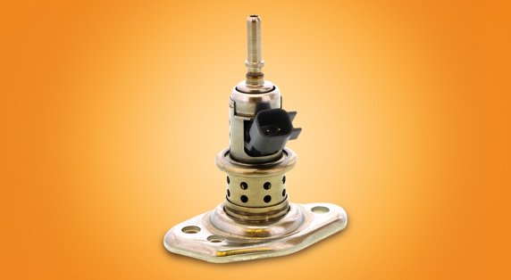
Continental-Diesel-Aftermarket-Injectors.jpg |  | Continental offers an OEM Diesel Aftertreatment Injector for popular Ram models.

299-23/CO8586

