Press release

ess Release

Press Release

Press Release

Press Release

Press Release

Press Release

Press Release

Press Release

ess Release

Press Release

Press Release

Press Release

Press Release

Press Release

Press Release

Press Release

Press Release

ess Release

Press Release

Press Release

Press Release

Press Release

Press Release

Press Release

Press Release

ess Release

Press Release

Press Release

Press Release

Press Release

Press Release

Press Release

Press Release

Press Release

ess Release

Press Release

Press Release

Press Release

Press Release

Press Release

Press Release

Press Release

ess Release

Press Release

Press Release

Press Release

Press Release

Press Release

Press Release

Press Release

Press Release

ess Release

Press Release

Press Release

Press Release

Press Release

Press Release

Press Release

Press Release

ess Release

Press Release

Press Release

Press Release

Press Release

Press Release

Press Release

Press Release

ConExpo/ConAgg 2023
Advanced Surround View from Continental ProViu 360 Makes Driving Safer for Construction Equipment
• 2nd generation, all digital system delivers 360 degree bird’s eye view of vehicle in HD
• Makes driving easier and safer, reducing driver stress and risk of accidents
• Upcoming new features improve overall safety

Las Vegas, NV, March 14, 2023 – Continental has introduced the next generation of its innovative surround view camera technology for construction and mining vehicles. The new ProViu® 360 2nd Generation Surround View System provides full digital capabilities that give drivers and operators even sharper and higher quality images in HD resolution so they can easily and safely monitor their entire vehicle and its surroundings at a single glance. The ProViu 360 system is an ideal solution for reducing driver stress and increasing efficiency in commercial vehicles, heavy duty trucks, mining, and construction equipment.

A virtual bird’s eye view
The new ProViu 360 camera system’s 360-degree capability maximizes the field of view and eliminates the blind spots. Using four high-performance HD automotive cameras to cover every direction around the vehicle, ProViu 360 creates a virtual bird’s eye view of the entire vehicle in real time. The enhanced HD resolution image is displayed on a 10” HD touch screen monitor for easy viewing by the driver.

New safety features coming soon
To help improve overall safety in construction and mining applications, Continental has developed three new system features for the ProViu 360 that aid operators and drivers. The new features are Worker Detection, which identifies people near the vehicle and differentiates them from objects; Transparent Chassis, which allows operators to see “through” the vehicle they are operating, improving visibility; and Clean Camera Assist, which detects cameras that are dirty or blocked. The new features are based on technologies that Continental developed for passenger cars and has now optimized for work sites.

Improved vehicle safety, security, and efficiency
ProViu 360 can be used while the vehicle or machine is in motion or standing still. It makes drivers and operators fully aware of everything that’s happening around the vehicle when maneuvering through busy job sites. This capability gives operators a better view of obstacles, hazards, and fellow workers, so that the vehicle or equipment can be controlled in a much safer manner.
As a specialist in the fields of video processing, display technology, and camera applications, Continental combines all its expertise into the components of the ProViu 360 to create an advanced safety solution for vehicle monitoring. The Continental ProViu 360 2nd Generation Surround View System is easy to set up and simple to calibrate. It is compatible with CAN-Bus and other GPIOs and features a flexible software tool chain for easy customization to meet specific customer requirements.
Continental develops pioneering technologies and services for sustainable and connected mobility of people and their goods. Founded in 1871, the technology company offers safe, efficient, intelligent and affordable solutions for vehicles, machines, traffic and transportation. In 2021, Continental generated sales of €33.8 billion and currently employs more than 190,000 people in 58 countries and markets. On October 8, 2021, the company celebrated its 150th anniversary.
Continental offers a wide-ranging portfolio for off-highway applications which makes construction, agricultural and transport machinery and vehicles safer, more efficient, more comfortable and more connected. The corporation supplies interdivisional solutions for monitoring the condition of components and systems as well as technologies for information management, rubber and plastic products, and tires – all tailor-made and from a single source.

Press contact

Anouré Fenstermaker
Marketing Communications Manager, North America
Smart Mobility
Phone: +1 (484) 705-1909‬‬‬‬‬‬‬‬‬‬‬

Email: Anoure.Fenstermaker@continental-corporation.com

Press portal: www.continentalaftermarket.com/conexpo

pictures/captions

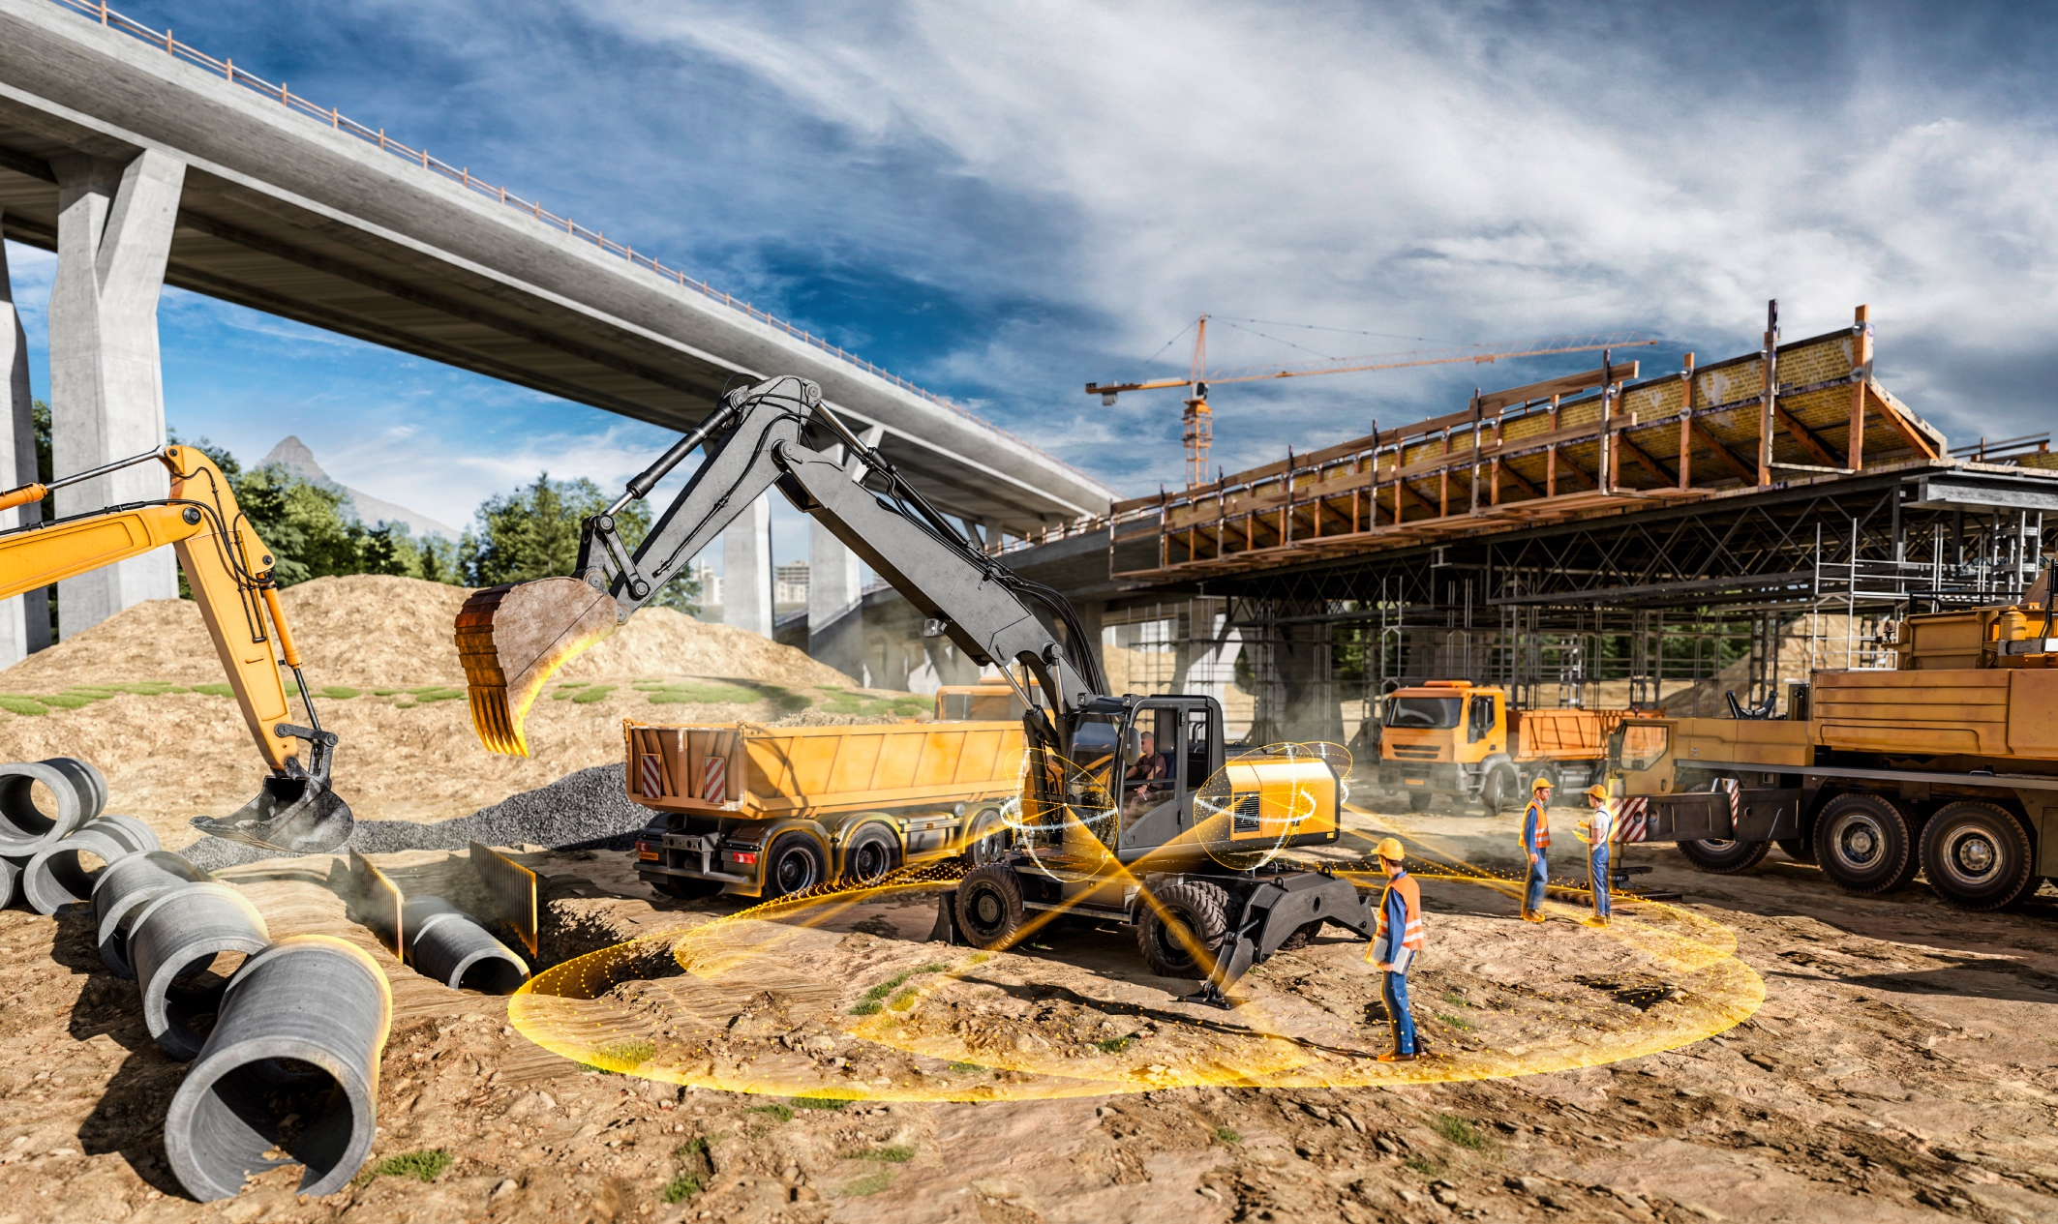
Continental ProViu® 360 improves visibility and safety on construction sites.

continental_pp_proviu360_excavator.jpg

