Continental Expands OEM Knock Sensors Line for Popular Domestic, European, and Asian Makes
- Covers Chrysler, Dodge, Ford, Infiniti, Jeep, Lincoln, Mercedes-Benz, Mercury, Nissan, Ram
- Eight SKUs cover 30 million vehicles in operation in the United States, Canada
- Made in ISO-certified facilities, provide original fit and function
Las Vegas, NV, October 31, 2023 — Continental has added eight new part numbers to their original equipment manufacturer (OEM) Knock Sensors line. The sensors are the same part that the vehicle manufacturer uses and deliver the exact fit, form, and function as the original part, ensuring an easy installation and long service life.
Millions of vehicles covered
Continental’s eight new Knock Sensor part numbers provide application coverage for some of the most popular domestic, European, and Asian makes and models on the road today. The expanded line covers Chrysler, Dodge, Ford, Infiniti, Jeep, Lincoln, Mercedes-Benz, Mercury, Nissan, and Ram models ranging from 2000 to 2023. The new sensors provide coverage for 28,814,500 vehicles in operation (VIO) in the United States and 2,438,395 vehicles in Canada.
“Our newly expanded line was developed to meet the growing need for reliable knock sensors on some of the most common vehicles on the road today,” noted Brendan Bachant, Continental Product Manager for Engine Management and Fuel. “The original sensors can be prone to failure due to mechanical damage, excessive vibration, high engine temperatures, and corrosion. Continental has made these OEM sensors available to the aftermarket so that professional technicians can easily and confidently service the most common vehicles in the shop, like the Ford F-150 and Explorer, the Jeep Wrangler, and the Nissan Maxima and Altima. Technicians can be confident when choosing the Continental Knock Sensor that they will avoid comebacks.”

Knock sensors are designed to detect engine ping caused by pre-ignition and relay the information to the electronic control unit to adjust engine timing and help keep the engine running smoothly. These sensors are an ideal repair for a rough running engine with a timing and knock sensor fault code and will help shops to restore the performance of their customers’ vehicles to OE specifications.
Continental Knock Sensors are built in International Organization for Standardization (ISO)-certified facilities to deliver the highest level of dependability.
Continental is a leading aftermarket supplier of OE-engineered parts for HVAC and engine cooling, door systems, tire pressure monitoring systems, engine management, fuel systems, instrumentation, as well as automotive diagnostic systems, premium wiper blades, air, cabin, fuel, and oil filters, and brake system parts and fluid.

For more information, visit: continentalaftermarket.com
or contact: salessupport-us@continental.com

Continental develops pioneering technologies and services for sustainable and connected mobility of people and their goods. Founded in 1871, the technology company offers safe, efficient, intelligent and affordable solutions for vehicles, machines, traffic and transportation. In 2022, Continental generated sales of €39.4 billion and currently employs around 200,000 people in 57 countries and markets.
Drawing on more than 120 years of cooperation with vehicle manufacturers, Continental offers a broad range of spare parts in OEM quality for the aftermarket. Under brands like Continental, ATE, VDO,
REDI-Sensor, ClearContact, Autodiagnos, Uniroyal, Semperit, and GALFER, the technology company manufactures tens of thousands of products, including tires, brakes, drive components and thermal management components. It also provides diagnostic solutions, tools and services for repair shops. Continental is one of the most important suppliers in the independent automotive aftermarket.

Press contact

Anouré V. Fenstermaker
Marketing Communications Manager
Continental Automotive Systems, Inc.
Automotive Aftermarket, North America
Smart Mobility (SMY)
6755 Snowdrift Road, Allentown, PA 18106
Tel: (484) 705-1909, Fax: (610) 289-1766
Email: anoure.fenstermaker@continental.com

Press portal: https://www.autoshowpress.com/continental-aapex/

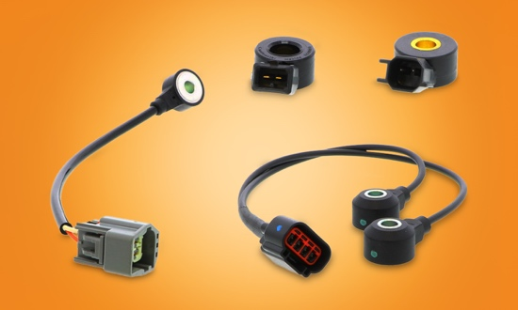
Continental-Knock-Sensors.jpeg |  | Continental has added eight new OEM Knock Sensors to its product line.

299-23/CO8586

