Continental NightViu® Commercial Lighting Line Now Available to Off-Road Consumer Markets
- Pro-quality LED lights now available for off-roaders, boat owners, other consumers
- IP rated housings stand up to intense vibration, harsh conditions
- Low power consumption, high energy efficiency
Las Vegas, NV, October 31, 2023 — Continental has just announced that the NightViu® premium lighting line of professional driving and working lights will be made available to consumer markets including off-road enthusiasts, recreational vehicles (RV), and marine. Originally designed for use on construction, mining, and off-highway equipment, the NightViu® lighting line provides a level of rugged design, durability, and performance not normally seen in consumer lighting products.
Built to withstand extreme temperatures, vibration, dust, and moisture, NightViu lights feature advanced Light Emitting Diode(LED) technology that provides excellent lighting performance and exceptional energy efficiency. NightViu® Driving Lights provide a focused beam of light for long-distance illumination. They are perfect for applications such as desert/rally racing or any activity where maximum beam distance is required. NightViu® Working Lights provide beams that are shorter but wider. This makes them suitable for applications such as rock crawling, lighting up pick-up beds, and sport fishing boats.
According to Edwin Betancourt Jr, Product Manager, Continental, “The NightViu® line was created for some of the toughest applications you can imagine including mining, construction, and agriculture. Some might consider them over-engineered for consumer applications, but we believe there are folks out there who simply want the best they can get for their lighting. That’s why we’ve decided to make NightViu® available for off-road enthusiasts, RV owners, and others who want a professional level light source for their off-road activities. These lights can be used for ATVs, UTVs, and SUVs, as well as Jeeps, snowmobiles, work trucks, and even riding lawn mowers and go-karts. The build quality and housing seals make them suitable for marine applications as well including blue water cruising and fishing.”

NightViu® Working Lights are available in a choice of ultra-wide, wide, flood, and spot beam patterns. Each of the Working Lights beam patterns is offered in a choice of 1,500, 2,500, 3,500, and 4,500 lumen performance for a total of 16 lights in the NightViu® Working Lights range. NightViu® Driving Lights are available in a variety of designs and configurations including five light bars, three multifunctional lights, and two reversing lights. They provide up to 5,500 lumens and a beam field length of up to 440 meters. The lights feature free-form curved reflectors that direct the light beam exactly where it’s needed.
Tested to withstand real-world demands
NightViu® Lights are built to withstand temperatures ranging from -40 F to 194 F and are rated IP68 for Ingress Protection (IP) from dust and water. They are highly energy efficient compared to traditional LED lighting. They produce approximately 100 lumens per watt and have been designed to ensure that they do not create electrical interference that could affect the vehicles existing electronics.
Continental develops pioneering technologies and services for sustainable and connected mobility of people and their goods. Founded in 1871, the technology company offers safe, efficient, intelligent and affordable solutions for vehicles, machines, traffic and transportation. In 2022, Continental generated sales of €39.4 billion and currently employs around 200,000 people in 57 countries and markets.
Drawing on more than 120 years of cooperation with vehicle manufacturers, Continental offers a broad range of spare parts in OEM quality for the aftermarket. Under brands like Continental, ATE, VDO,
REDI-Sensor, ClearContact, Autodiagnos, Uniroyal, Semperit, and GALFER, the technology company manufactures tens of thousands of products, including tires, brakes, drive components and thermal management components. It also provides diagnostic solutions, tools and services for repair shops. Continental is one of the most important suppliers in the independent automotive aftermarket.

Press contact

Anouré V. Fenstermaker
Marketing Communications Manager
Continental Automotive Systems, Inc.
Automotive Aftermarket, North America
Smart Mobility (SMY)
6755 Snowdrift Road, Allentown, PA 18106
Tel: (484) 705-1909, Fax: (610) 289-1766
Email: anoure.fenstermaker@continental.com

Press portal: https://www.autoshowpress.com/continental-aapex/

NightViu on ATV.jpeg |  | Continental NightViu® Lights are now available for off-road consumer applications.
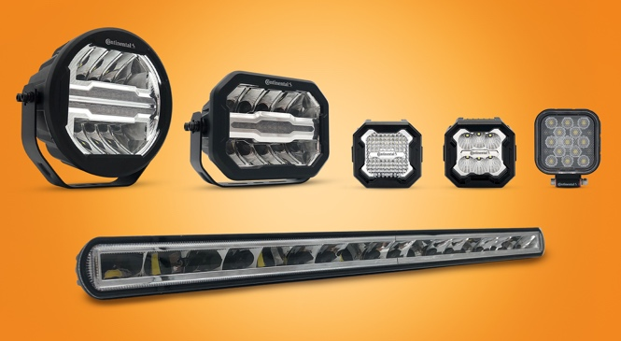  NightViu Lights for Off-Road.jpg | Continental NightViu® Lights combine advanced  LED technology with rugged die-cast  aluminum housings.

299-23/CO8586

