ConExpo/ConAgg 2023

Continental Introduces NightViu® Premium Lighting Line for Construction and Off-Highway Applications
- LED lighting line includes new Working Lights and Driving Lights
- Robust and durable housings stand up to intense vibration, harsh conditions
- Uniform illumination improves visibility, reduces shadows
- Low power consumption, high energy efficiency

Las Vegas, NV, March 14, 2023 — Continental has introduced a new, premium lighting line designed for use on construction, mining, and off-highway equipment. The NightViu® Lighting line has been designed to help improve job site safety by dramatically increasing nighttime visibility. The line includes a wide variety of lighting solutions, each designed to meet specific application needs. Featuring durable and compact housings, NightViu® LED Lights are built to withstand the harsh conditions found in construction and mining. They can easily withstand high vibration, dust, moisture, extreme cold, and intense heat. The lights combine advanced LED technology with the latest innovations in indirect lighting to provide excellent lighting performance and exceptional energy efficiency.
NightViu Working Lights for near and far
With a choice of ultra-wide, wide, flood, and spot beam patterns, NightViu® Working Lights enable operators to spot obstacles and hazards around the entire job site. Each of the Working Lights beam patterns is offered in a choice of 1,500, 2,500, 3,500, and 4,500 lumen performance for a total of 16 lights in the NightViu® Working Lights range.
Driving Light designs engineered for specific needs
NightViu Driving Lights are available in a variety of designs and LED configurations including light bars, multifunctional lights, and reversing lights. They provide up to 5,500 lumens and a beam field length of up to 440 meters. Their uniform illumination improves visibility and reduces shadows so operators can maneuver the job site fully aware of all hazards. The lights feature free-form curved reflectors that direct the light beam exactly where it’s needed.
Tested to withstand real-world demands
NightViu Lights are built to withstand temperatures ranging from -40 F to 194 F and are rated IP68 for Ingress Protection (IP) from dust and water. Plus, they are energy efficient compared to traditional LED lighting for construction machinery. They produce approximately 100 lumens per watt and have been designed to ensure that they do not create electrical interference that could affect the vehicles existing electronics.
“The new line of NightViu Working and Driving Lights represents a meaningful contribution to construction, mining, and off-highway safety,” notes Edwin Betancourt Jr, Product Manager, Continental. “With more construction and mining work being conducted before sunrise and after sunset, the importance of adequate lighting becomes crucial to maintaining a safe and efficient job site. These powerful technologies in advanced LED lights help reduce accidents by illuminating hazards, obstacles, and most importantly job site employees.”
Continental develops pioneering technologies and services for sustainable and connected mobility of people and their goods. Founded in 1871, the technology company offers safe, efficient, intelligent and affordable solutions for vehicles, machines, traffic and transportation. In 2021, Continental generated sales of €33.8 billion and currently employs more than 190,000 people in 58 countries and markets. On October 8, 2021, the company celebrated its 150th anniversary.
Continental offers a wide-ranging portfolio for off-highway applications which makes construction, agricultural and transport machinery and vehicles safer, more efficient, more comfortable and more connected. The corporation supplies interdivisional solutions for monitoring the condition of components and systems as well as technologies for information management, rubber and plastic products, and tires – all tailor-made and from a single source.

Press contact

Anouré Fenstermaker
Marketing Communications Manager, North America
Smart Mobility
Phone: +1 (484) 705-1909‬‬‬‬‬‬‬‬‬‬

Email: Anoure.Fenstermaker@continental-corporation.com

Press portal: www.continentalaftermarket.com/conexpo

pictures/captions
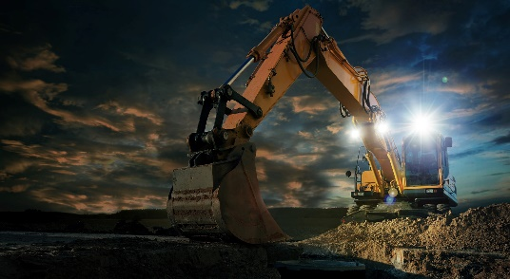  NightViu_construction1.jpg | Continental NightViu® lighting delivers exceptionally high energy efficiency.
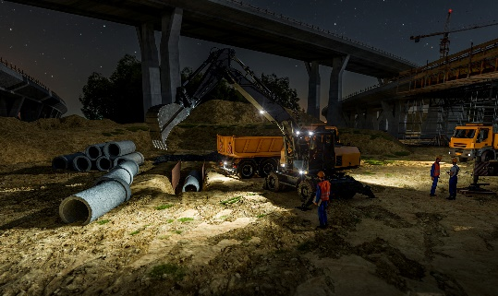  NightViu_construction2.jpg | Continental NightViu® Working Lights are available in 1,500, 2,500, and 3,500 lumen options and flood, spot, wide, and ultra-wide beam patterns.
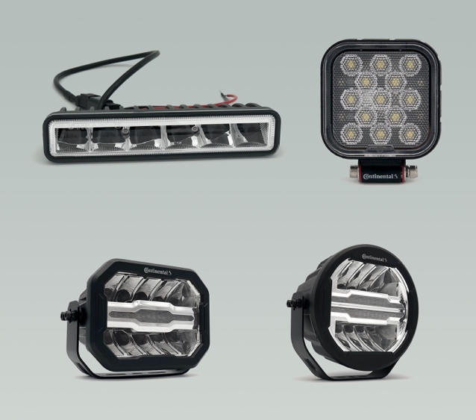  Continental NightViu Driving Lights.jpg | Continental NightViu® Driving Lights combines advanced LED technology with rugged die-cast aluminum housings.
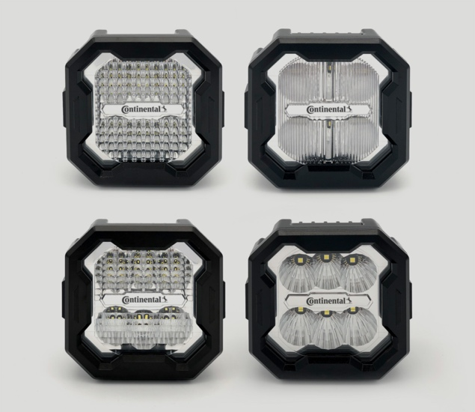  Continental NightViu Worklights.jpg | Continental NightViu® Work Lights are available in flood, spot, wide, and ultra-wide beam patterns.

